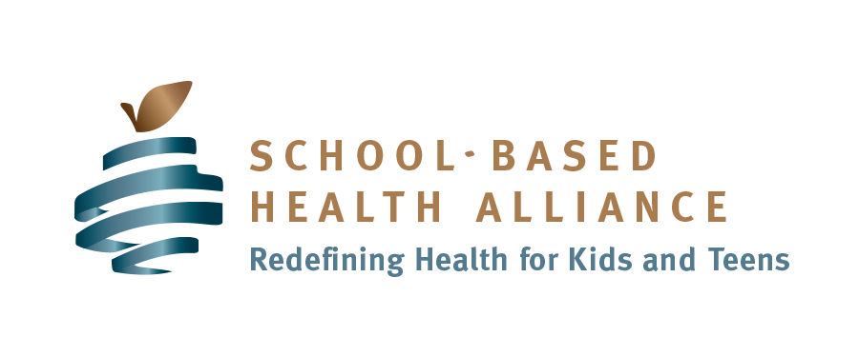

Year One - Workplan
Business Plan Section | Objective | Activities/Strategies | Date / Timeline: | Key Person(s) Responsible
Needs Statement | Develop a clear and concise statement of the need | - Complete Readiness Assessment  - Review Readiness Assessment  - Draft summary of needs statement based on Readiness Assessment Findings  - Convene partners and planning group members to review, edit, and finalize needs statement
Collaborating Partners | Create an SBHC collaborating partnership description | - List the name, title, and contact information for each partner organization’s liaison  - Indicate each member’s role and responsibilities (convener; local education agency, medical sponsor; behavioral health provider; other service provider(s); community, student, parent advisors; etc.  - Decide which partner organizations to include in the SBHC MOU
Vision and Mission Statement | Develop a clear and concise statement of the SBHC’s  mission and vision | - Review collaborating partners’ vision and mission statements and assess compatibility  - Convene partners, planning group members, parents, and students in a group vision and mission statement activity
Goal Statement and Y1 Objectives | Develop a goal and supporting objectives to drive the SBHC’s programmatic direction | - Define a goal statement with desired outcomes and accomplishments the SBHC will achieve in the first three years  - Create Y1 Objectives that are specific, measurable, realistic, and time-bound (SMART) actions to support goal statement in year 1
Services and Staffing | Determine SBHC services and required staffing | - Specify the services available at the SBHC, based on the market analysis data  - Create a staffing matrix, including positions, qualifications, responsibilities, and weekly hours  - Define management and supervisory structure for SBHC staff  - Determine hiring plans and partner involvement for each position
Location, Facilities, and Equipment | Develop an SBHC facilities plan | - Identify possible location(s) in or on school grounds to accommodate the SBHC and services to be provided  - Select the SBHC location  - Determine renovation or capital improvements needed  - Describe physical location(s) for SBHC service delivery  - Describe square footage of location(s) for SBHC service delivery (including number and functions of rooms).  - Include architectural drawing(s) of SBHC space(s)  - Develop list of SBHC equipment
Marketing and Outreach | Develop an SBHC marketing and outreach plan | - Conduct marketing training for collaborating partners  - Translate SBHC services into marketing terms (audiences, gatekeepers, messaging) and concepts (product, placement, price, promotion)  - Develop messages/taglines for each audience (school staff, parents, students)  - Develop promotional materials/vehicles/strategies for each audience (school staff, parents, students)  - Employ promotional materials and strategies with each target audience (school staff, parents, students) to drive SBHC enrollment, utilization, and outcomes
Pro-Forma Summary | Complete an SBHC financial projection for year one | - Educate collaborating partners on costs and revenue associated with an SBHC  - Train collaborating partners on how to use a Pro-forma business plan to project SBHC expenses and revenue over four years  - Complete a year-one SBHC Pro-forma business plan to implement
Optional Sections – beyond year one
Exit Planning | Determine ahead for potential change(s) in services or sponsorship to ensure continuity of care | - Agree on notice each partner will provide (minimum of 3 months notice and six months preferred)  - Determine transition plan (time, transfer of patients, payment of debtors, notification of funders, assets including space, equipment, records, etc.)  - Include in MOU
Executive Summary | Highlight key points from the Y1 SBHC Business Plan | - Distill business plan essentials into an abbreviated, one-page document for easy comprehension  - Create Executive Summary after all other business plan sections are complete
Market Analysis | Prepare an SBHC market analysis | - Describe SBHC target audience(s)  - Describe current and projected needs of the target audience(s) from readiness assessment data and other data collection activities (surveys, focus groups, interviews)  - Describe geographic service area and demographics of the target audience(s)  - Include availability of similar programs  - Discuss comparative advantage(s) of SBHC services  - Discuss challenges and opportunities the SBHC will face in the first year
Risk Management | Consider risks the SBHC may encounter and a plan to reduce them. | - Provider background checks  - Basic safety training (CPR, Blood-borne pathogens, etc.)  - Hostility

